Data Sources: openweathermap (<https://openweathermap.org/api/one-call-3>)

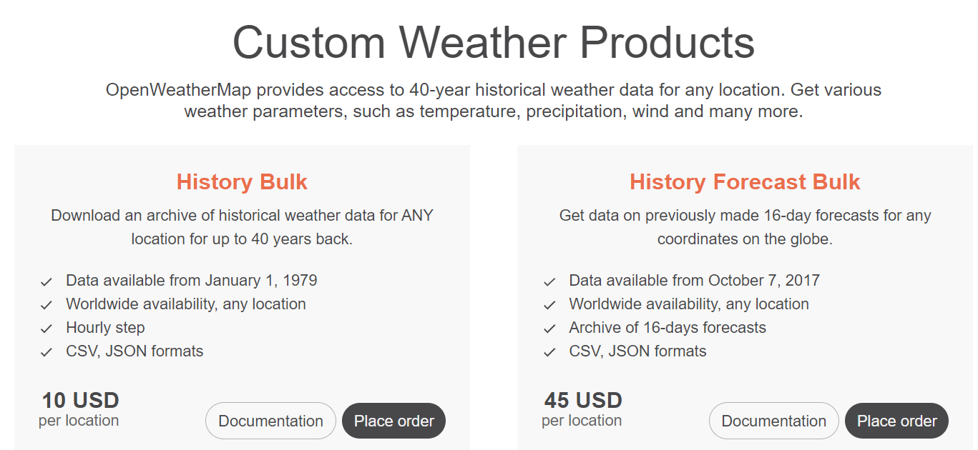

One Call API 3.0 is included to the “One call by call” subscription plan only, users pay for the actual use of the product. There are no limits on the number of API calls, but you can set API calls limit per day in the ["Billing plans" tab](https://home.openweathermap.org/subscriptions) in your Personal account.

Please note, that you do not need to subscribe to any other OpenWeather subscription plans to get access to the One Call API 3.0. Read more about this subscription plan in the [**FAQ**](https://openweathermap.org/faq#onecall).

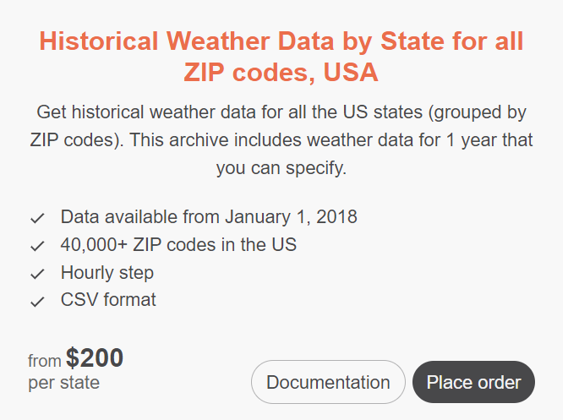

Meteomatics

Weatherstack <https://weatherstack.com/product> (has a subscription plan)

Wunderground scraping (won’t work chromedriver was updated, google chrome browser was updated)

Weatherkit Apple (historical

Weatherbit (no historical data)

AerisWeather **NO**

**POST**

**TEXAS HEAT EXPLAINED**



I decided to do this analysis to settle a silly debate my dad and I had on which Texas month was hotter: July or August. He believed August was the hottest month, and the weather got progressively hotter from June - August; I thought July was the hottest month.

* Show June - August 2023 weather data (covered by open weather map)
* Calculate the highest temperature in each month (given by owm)
* Calculate the weighted average highest temperature for each summer month
* Calculate how long the heat lingers (how many hours it stays above triple digits) (No one keeps hourly data)
* Calculate feels like temperature
* Calculate weighted average feels like temperature
* Show number of consecutive hot days

Repeat same for historical trends

Different ways to define hottest months;

Weighted average of highest temperature across months, highest feels like temperature, when did the heat linger the longest (heat duration)